Onkaparinga Council Report

JANUARY 2022
Prepared by Thalassa Ward Cr Marion Themeliotis. If you have any local issues, you would like me to follow up on or require any assistance with Council, please do not hesitate to contact me.

Mobile: 0413 747 351
Email: marion.themeliotis@onkaparinga.sa.gov.au
Facebook: facebook.com/Cr-Marion-Themeliotis-City-of-Onkaparinga-Thalassa-Ward

RAT Tests | IMPORTANT – How to safely dispose of used Rapid Antigen Test Kits (RATs)  RATs ARE NOT RECYCLABLE!  Not only are the home test kit materials not recyclable, but you could also put yourself and our workers at risk, by trying to break them apart for recycling.  PUT THEM IN A SEALED PLASTIC BAG AND DISCARD IN YOUR RED LANDFILL BIN  Your RAT kit should come with disposal information to follow.  Some tests also come with a small plastic bag to place the contents of the test into (including the swab).  If no bag is provided, you can use your own sealable plastic bag. (eg. sandwich bag)  The tightly sealed bag can then be discarded in your household waste bin.  SANITISE YOUR HANDS  It's important to wash or sanitise your hands effectively after completing the test and disposing of the test kit contents.  Please share this important message with your family, friends and networks!
Graffiti removal | Graffiti concerns everyone in the community. It is costly, unsightly and makes some people feel unsafe. Our graffiti management program works with residents, community groups and government agencies to reduce graffiti and its impact.  Graffiti vandalism on your property is a crime and should always, in the first instance, be reported to SA Police on  131 444.  We provide:  - free removal from your property boundary for those deemed to be of ill health, with a disability, or who are frail aged  - free removal from your property boundary, at council’s discretion, for the first reported graffiti, then regulated volumes of free materials for you to remove future graffiti from your property  subsidised removal for businesses.  Find out more here: https://www.onkaparingacity.com/Services-and.../Graffiti
Australia Day Bush Fair and Breakfasts | PLEASE TAKE NOTE AUSTRALIA DAY BREAKFASTS & BUSH FAIR CANCELLED!  With the challenges posed by the current COVID-19 situation, we've had to reconsider activities planned for Australia Day.  Front of mind during those considerations was the safety of our staff, elected members, valued volunteers and residents, and balancing those safety and welfare concerns with the importance of Australia Day celebrations.  After much discussion, we've decided to cancel our annual Australia Day Bush Fair event and Australia Day Breakfasts.  Our Australia Day citizenship ceremony will be held virtually to ensure the safety of staff, and it will also allow participants to have family and friends in virtual attendance.
My Local Services App | The My Local Services app offers a quick calendar check. You can also subscribe to receive notifications each week with which bins to put out.  Find out more or download here: https://www.lga.sa.gov.au/.../part-of-your-everyday/mylocal  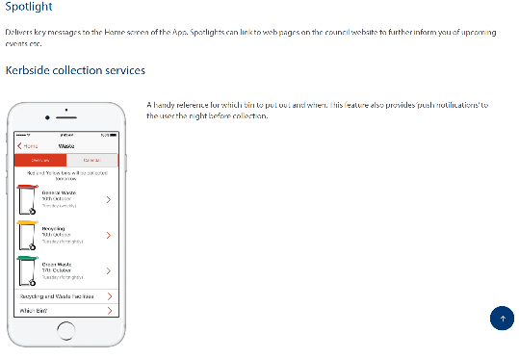
Request a green organics pass | Each residential property is entitled to one green organics pass per financial year.  This service is not available for businesses, community groups or sporting clubs.  Request a green organics pass online 2021-22 here: https://www.onkaparingacity.com/.../Request-a-Green...  Or call our Customer Relations team on 8384 0666  Pass requests are processed the following business day and mailed out to you.  Your green organics pass contains 15 tokens. Each token allows you to dispose of one cubic metre of green organics (equivalent to a standard 6x4 trailer).
Propose Childcare Centre – Flagstaff Hill | UPDATE – Please note that Council Assessment Panel (CAP) will be discussing this proposal on the 17th February.  - Petition of over 150 signatures received  - 37 Representation received  - 5 representors will speak at the CAP meeting
Cherry Gardens Road – Black Spot funding upgrades | 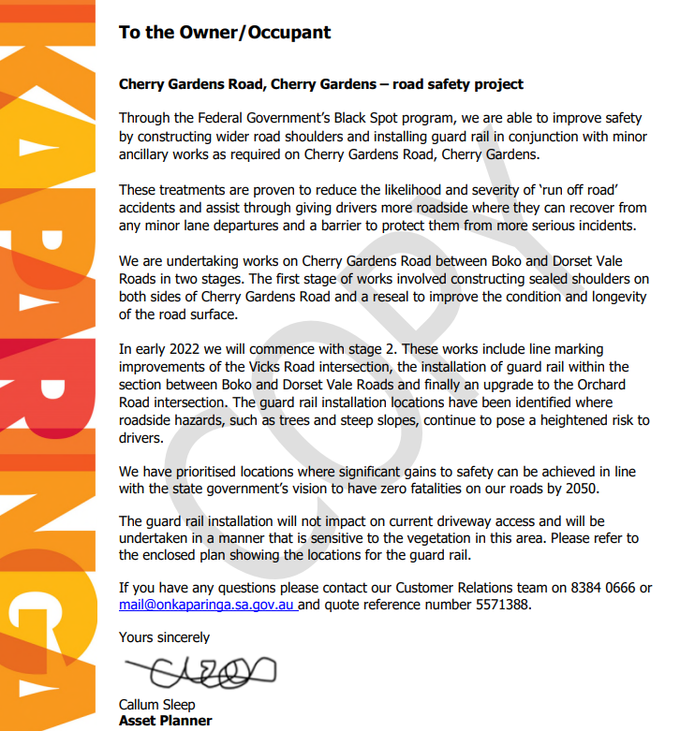  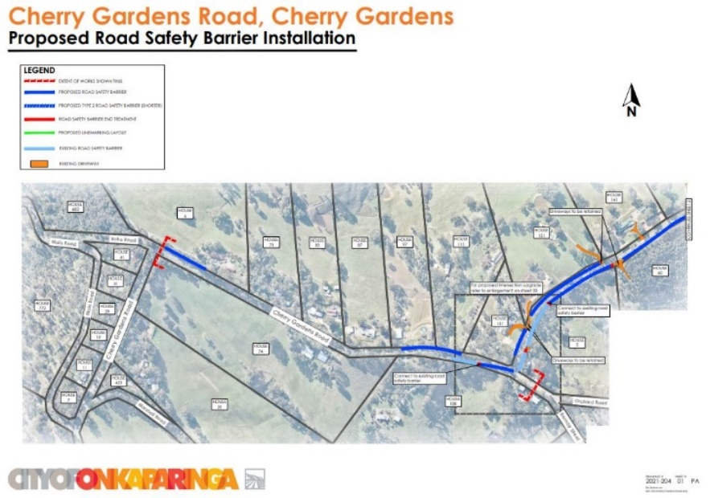  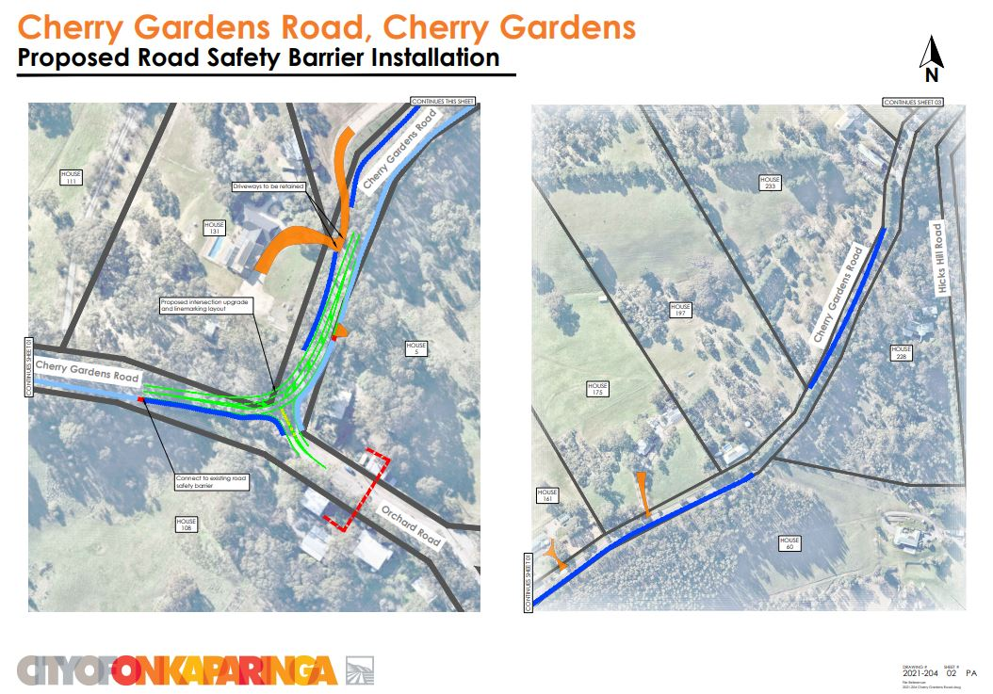  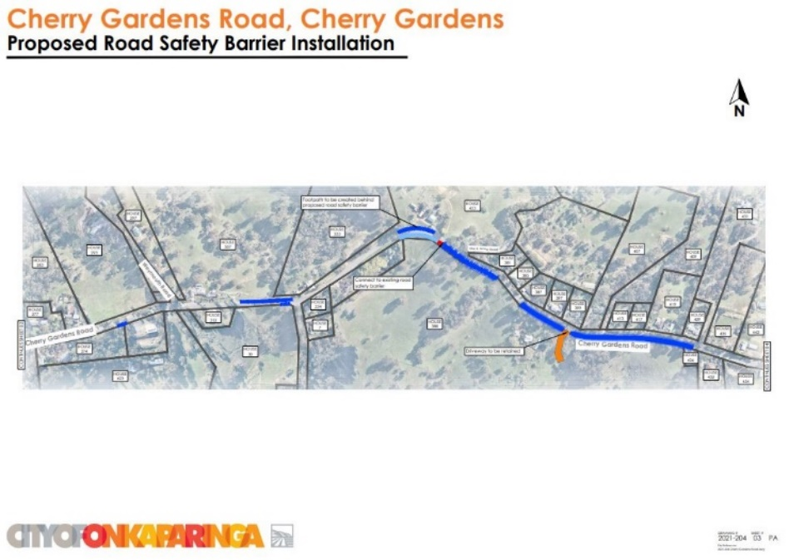  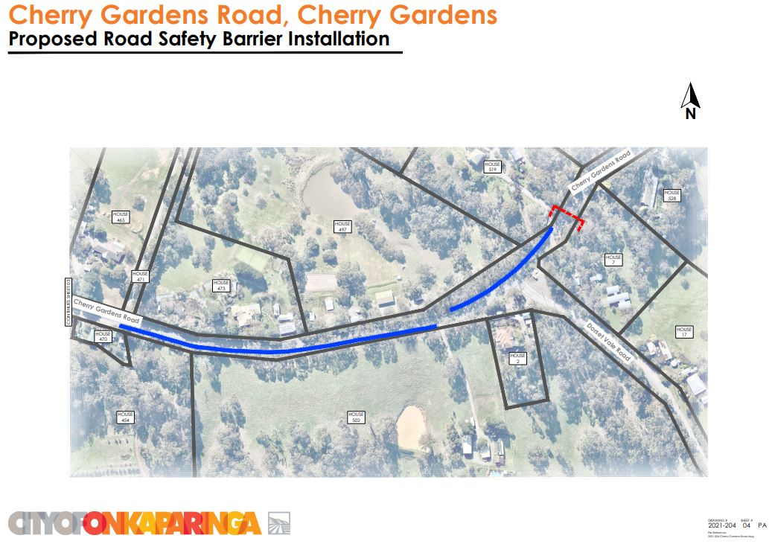
New Facebook Page | v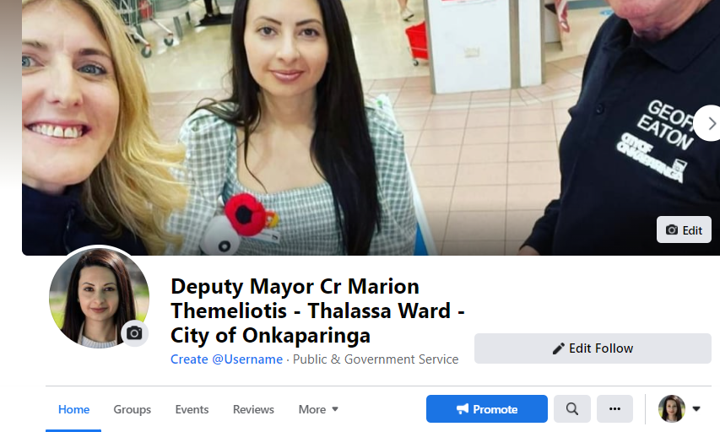  Keep up to date with everything happening at Council, through my new Facebook page.  You can follow the page here: Deputy Mayor Cr Marion Themeliotis - Thalassa Ward - City of Onkaparinga | Facebook

